- https://www.oracle.com/technetwork/java/javase/downloads/jdk8-downloads-2133151.html

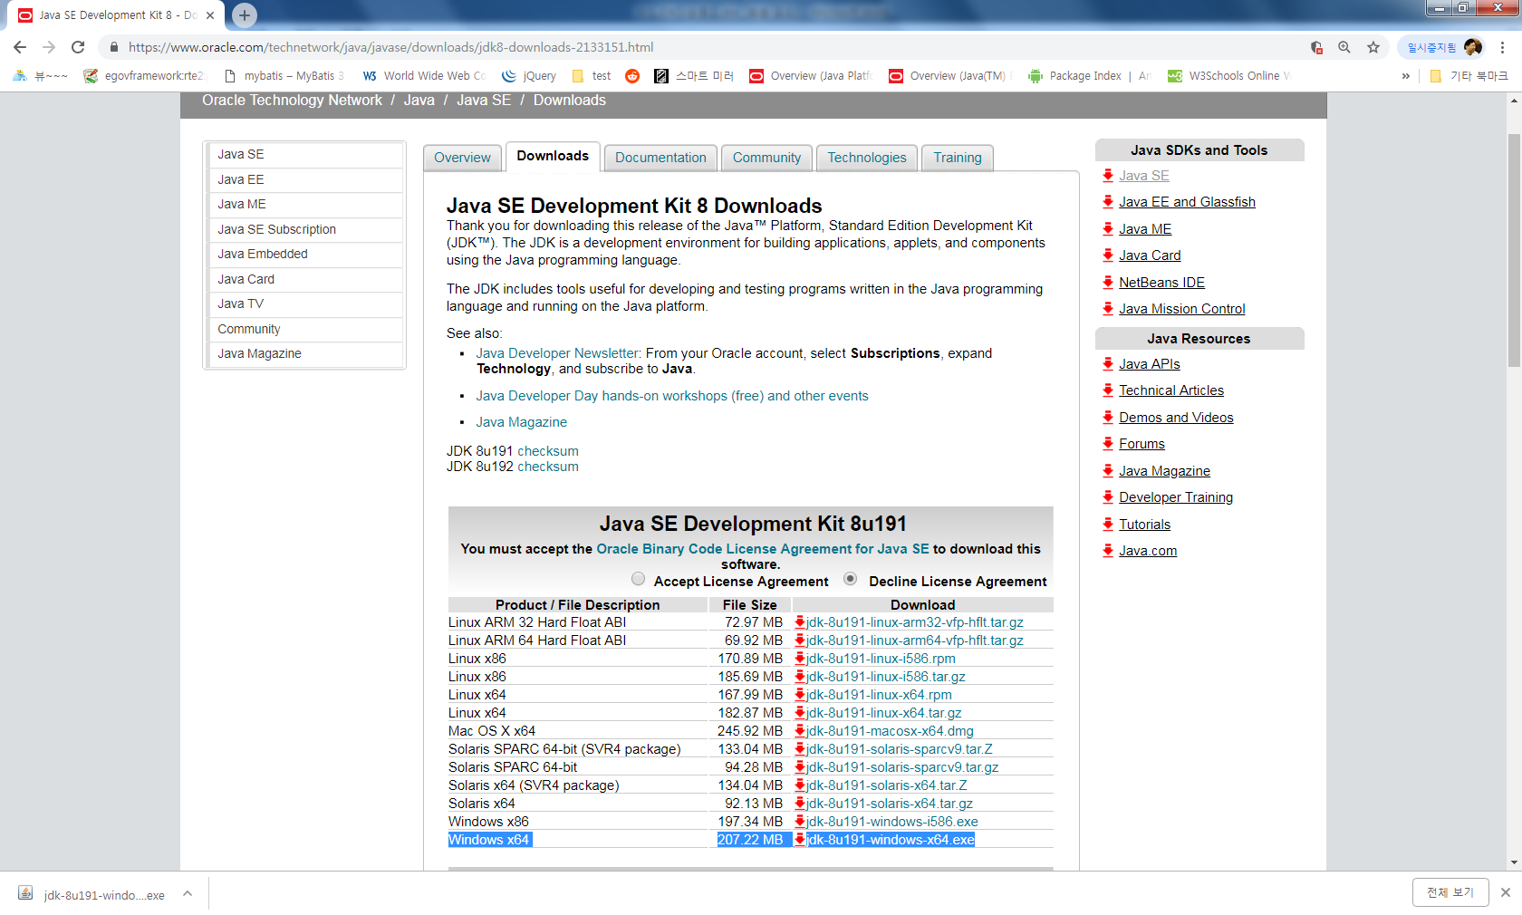

2. Accept License Agreement check → Windows x86 클릭

3. C:\JAVA_BIGDATA\99.TOOL 디렉토리에저장 저장
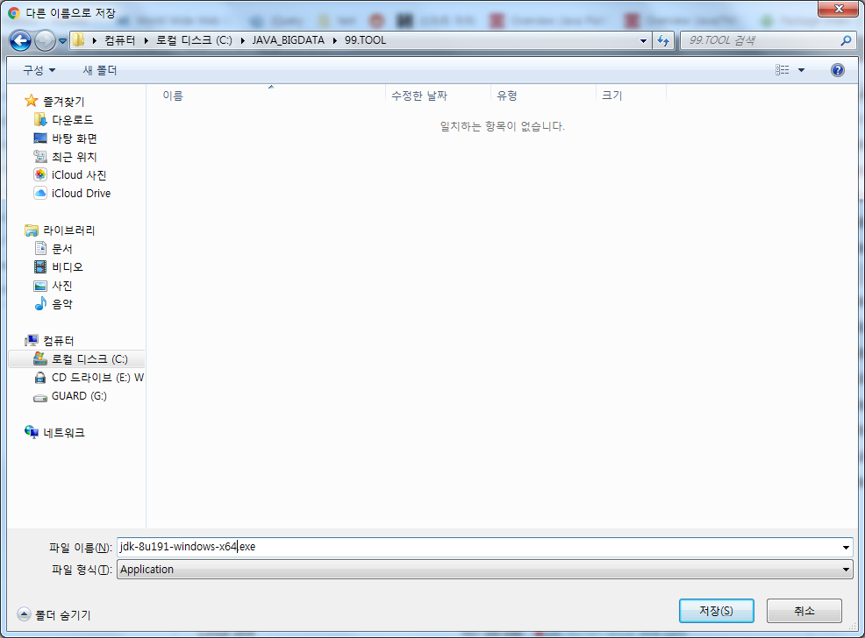

4.jdk-8u191-windows-x64.exe 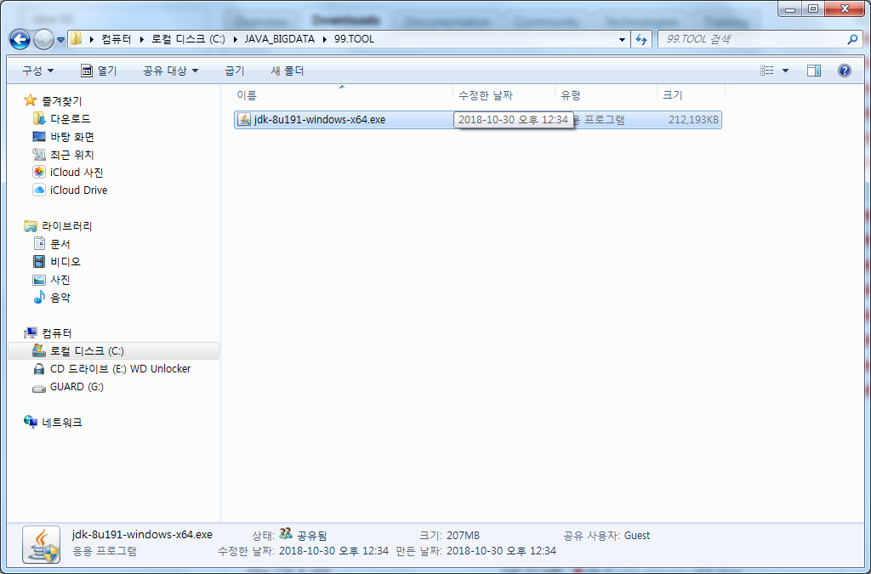
…

5 . jdk-8u191-windows-x64.exe 더블클릭

